SKEWNESS AND KURTOSIS
Kurtosis measures the “tailedness” of a distribution — how heavy or light the tails are compared to a normal distribution.
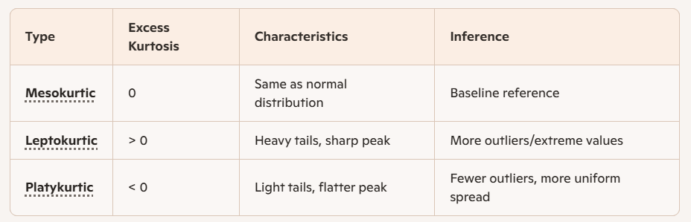
- High kurtosis (leptokurtic) → Data has more extreme values than normal. Risk of outliers is higher.
- Low kurtosis (platykurtic) → Data has fewer extreme values than normal. Distribution is flatter, more evenly spread.
- Normal kurtosis (mesokurtic) → Data behaves like a Gaussian distribution in terms of tail behavior.
Kurtosis is not about peakedness (height of the curve). It’s about tails and outliers.

Skewness measures the asymmetry of a distribution around its mean.
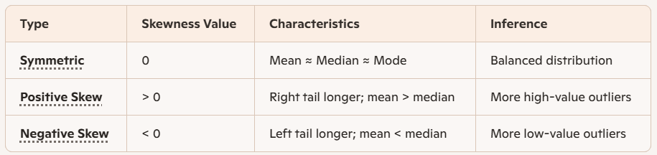
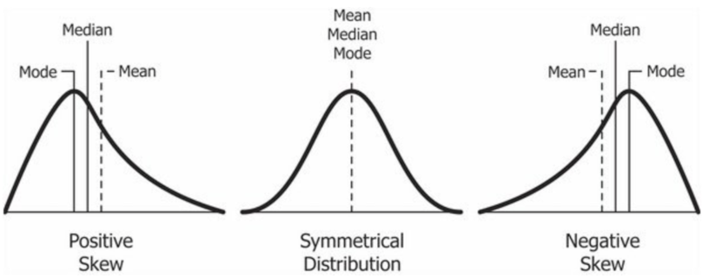
ANALYSIS:
Before replacing outliers,
 | sl_no | ssc_p | hsc_p | degree_p | etest_p | mba_p | salary
Skewness | 0 | -0.13265 | 0.163639 | 0.244917 | 0.282308 | 0.313576 | 3.569747
Kurtosis | -1.2 | -0.60751 | 0.450765 | 0.052143 | -1.08858 | -0.47072 | 18.54427

Salary data has high impact on outliers.
After replacing outliers,
 | sl_no | ssc_p | hsc_p | degree_p | etest_p | mba_p | salary
Skewness | 0 | -0.13265 | 0.162611 | 0.204164 | 0.282308 | 0.313576 | 0.8067
Kurtosis | -1.2 | -0.60751 | 0.086901 | -0.09749 | -1.08858 | -0.47072 | -0.23984

Comparitively the Skewness and kurtosis is reduced by replacing.
Ssc_p is slight negatively skewed, means lower values pull the mean downwards and Kurtosis is <0 (Platykurtic)
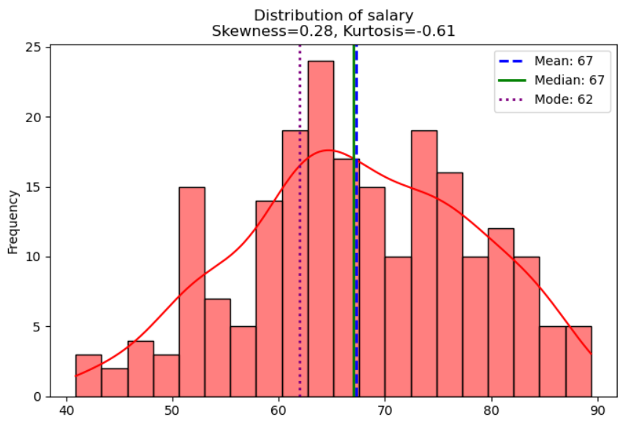
Etest_p is positively skewed and kurtosis is -1.0 (Platykurtic) means the flatter peak and light tails
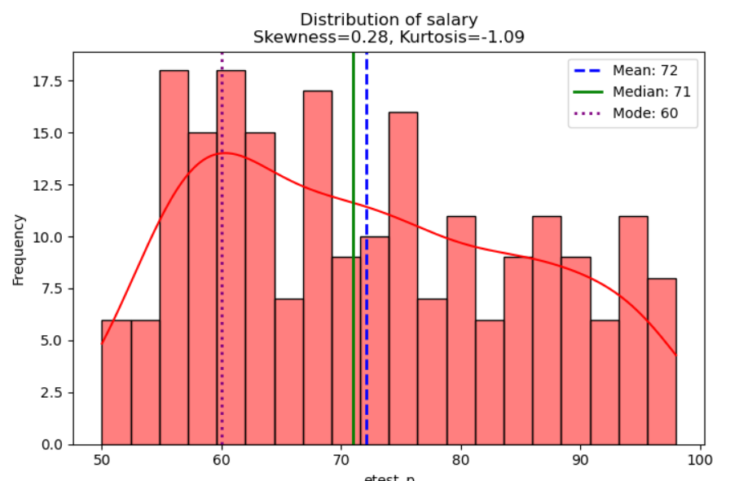
Salary is positively skewed and LeptoKurtic, means heavy tails and sharp peak. Some excess salary pulls the mean higher making positive skewness
